STAT 519/619 Final Project: Temporal Bias in Deadline-Style Prediction Markets using Polymarket
Jamie Sanson, Tyrell Jaques
30071105, 30019579
Dr. Haixu Wang
April 2026
AI-Use Disclaimer: AI was used as a coding assistant while developing parts of the SQL and Python workflow and as an editing aid for early report structuring. All SQL queries were executed locally by us, and all numerical results and plots reported in this document come from the actual database outputs and model runs. We reviewed and edited any AI-assisted text for accuracy and consistency with the implemented code. Moreover, as required by the course policy, we maintained a verbatim record of the prompts used to generate text and code.

Introduction
Polymarket is a prediction market platform where contracts pay $1 if an event occurs and $0 otherwise. In most markets, the “YES” token price trades between 0 and 1 and is commonly interpreted as an implied probability. A subset of Polymarket questions are deadline-style markets, meaning they ask whether an event will occur by a specified time (for example, “Will X happen by April 30?”). These markets are useful because they naturally create a time axis: the same underlying event can be priced repeatedly when the deadline is far away and then repriced as the deadline approaches.
A natural question in deadline markets is whether the market’s implied timing dynamics change with horizon. Even if the headline YES price is stable or drifts slightly downward, the same price level implies a very different “arrival rate” when there are 30 days left versus 1 day left. That is the core motivation for analyzing term structure in implied hazard rather than only modeling the probability level. A second motivation comes from behavioral work on time preferences: standard models such as hyperbolic discounting describe systematic differences in how people weight near-term versus long-term outcomes (Frederick, Loewenstein, & O’Donoghue, 2002). In markets, horizon effects could reflect behavioral time weighting, attention and information arrival near deadlines, or purely mechanical consequences of rescaling probabilities by remaining time. The point of this project is not to attribute the mechanism definitively, but to measure whether a systematic horizon effect exists and to quantify its magnitude with uncertainty.
Existing Methods
Most empirical work on prediction markets treats the YES price as an estimate of an underlying probability and models that probability directly as a function of time-to-deadline, for example with logistic regression or other generalized linear models. An alternative framing treats resolution as an arrival-time process and converts prices into an implied hazard rate using a survival-style mapping (Wolfers & Zitzewitz, 2004). The hazard framing is useful here because it separates the level of the probability from the time remaining: the same price implies very different short-horizon dynamics when there are 30 days left versus 1 day left. Our approach combines that mapping with a hierarchical model so we can estimate a shared horizon effect while controlling for large event-to-event differences in baseline rates.
Project Approach
This project’s research question is: after accounting for event-to-event heterogeneity, does the market-implied hazard increase as the deadline approaches, and how large is that effect on the hazard scale? As a motivating descriptive check, we first compute implied hazards at three reference horizons (about 30 days, 7 days, and 1 day before the deadline). Figure 1 shows that the implied hazard increases materially close to the deadline when summarized on the log scale. This motivates the hierarchical Bayesian model that follows, which estimates the horizon effects while pooling across related markets.
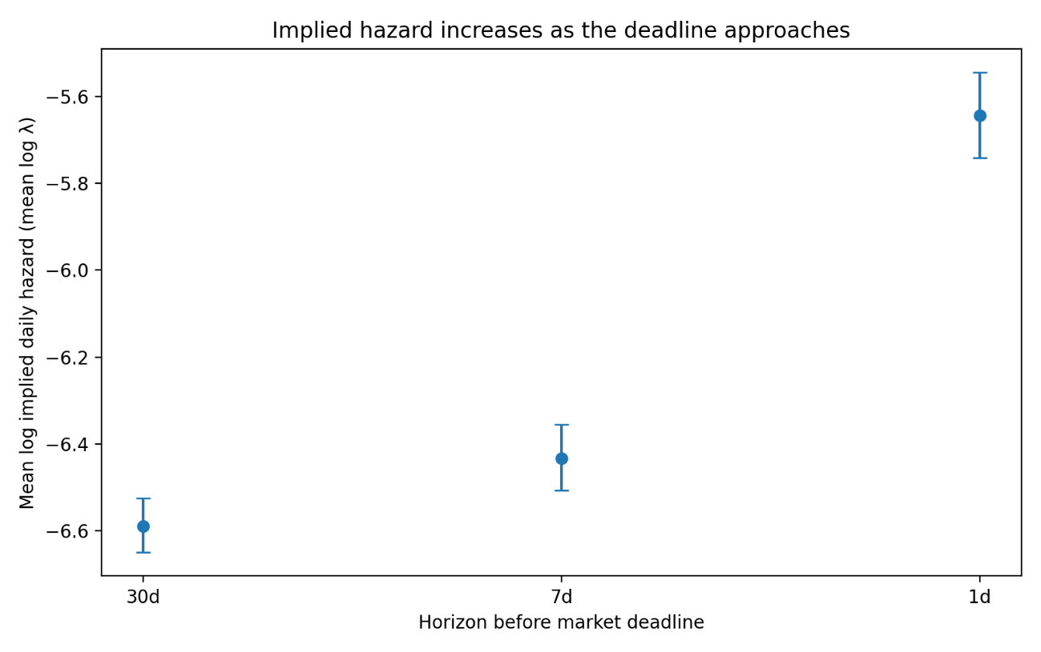
Figure 1. Mean log implied daily hazard (log λ) by horizon (30d, 7d, 1d). Points are sample means across markets in the modeling sample; error bars are 95% confidence intervals for the mean (normal approximation). The increase at 1 day is visually large relative to 30 days.
Data and Preprocessing
We worked from a local SQLite database constructed from Polymarket’s raw event exports. The database contains an events table and a markets table; market-level information was originally nested in events.markets as a JSON and was flattened into a relational markets table during preprocessing. After flattening, the full markets table contains 523,699 market objects.
We then filtered to deadline-style markets using a text-based heuristic to the market question strings. The filter searches for phrases that usually signal deadlines (e.g., “by”, “before”, “until” , “no later than”, etc.), and it explicitly excluded common sports-related false positives (e.g., “win by more than”, “by at least”, etc.). This filtering step was iteratively refined through manual inspection of roughly 2,000 sampled markets and produced 12,030 markets that plausibly represent deadline-style questions.
Price data is found in price_history, keyed by token_id. Each market has multiple outcome tokens; for our main analysis we restrict to the “YES” outcome and join on its token_id. We used a view (bets_for_timing_view) that consolidates the timing-market set and exposes the YES token_id in a way that is easy to join against price_history. We then computed the time-to-deadline in days for each price observation, which produced a long table with one row per market-price observation.
Moreover, it should be noted that not every market has dense pricing near all three horizons. We therefore distinguished between (i) the snapshot table, which records the nearest available observation to each horizon for markets with sufficient coverage, and (ii) the stricter modeling sample, which enforces that the chosen snapshots are actually close to their intended horizons. In our current run, the snapshot table contains 6,724 markets with non-missing values at all three horizons. For the Bayesian model, we enforced a “horizon purity” filter so that the 30-day snapshot is within 7 days of 30, and the 7-day and 1-day snapshots are each within 2 days of their targets. Doing so yielded 2,028 markets in the modeling sample (6,084 horizon observations)
Finally, we computed implied event-arrival rates from these prices. Under a constant hazard model with daily rate λ, the probability that an event occurs by time t (in days) is $P(t)=1−exp(−λt)$. Solving for λ in terms of an observed probability p at horizon t gives us $λ=\frac{−log(1−p)}{t}$. We used the YES token price as p and the time-to-deadline (in days) as t to compute an implied daily hazard at each horizon snapshot. Thus, for each market our final analysis table contains (i) the three snapshot prices, (ii) three implied rates, (iii) their log transforms, and (iv) the between-horizon deltas used in modeling. In our current run, the wide table contains 6,724 markets with sufficient data coverage to compute the horizon quantities. All SQL used to build our tables is recorded verbatim in analysis_pipeline.sql and was executed in Beekeeper Studio’s SQLite GUI (Beekeeper Studio, n.d). The final exported analysis table we used for modeling (with covariates included) is timing_model_input_bft_cov2.csv.
Covariates (local price activity)
In addition to prices, we extracted a time-local covariate that proxies for market activity and information flow around each snapshot timestamp. For each YES token and each horizon snapshot, we computed the 24-hour price range immediately preceding the snapshot:
$${price}_{}h=max(price∈prior24h)−min(price∈prior24h)$$
This captures local volatility or “activity intensity” in the period just before the snapshot. Because the raw range is right-skewed, we use log(1 + price_range_24h) and standardize it before modeling. We explored static market-level variables such as liquidity and 24-hour volume as additional covariates, but these fields were too sparse in the filtered modeling sample to include in the final fitted specification. The final covariate-augmented model therefore uses standardized log(1 + price_range_24h) as the primary activity covariate.
Model specification
The key modeling move is to work on the implied hazard scale rather than directly on price levels. Price is a probability-like level. Hazard is a timing rate. For the same p, the implied λ is much larger when t is small than when t is large, which makes hazard a natural object for studying horizon effects.
For market i and horizon $hϵ\{30,7,1\},$ we let $p_{\{i,h\}}$be the YES price observed at the selected snapshot, and let $t_{\{i,h\}}$ be the days remaining to the deadline at that timestamp. We then compute $λ_{\{i,h\}}=\frac{−log(1−p_{\{i,h\}})}{t_{\{i,h\}}}$ , and define the modeled response as: $y_{\{i,h\}}=log(λ_{\{i,h\}})$. By working on the log-rate scale, horizon effects become interpretable as multiplicative changes in λ.
Moreover, markets differ dramatically in baseline likelihood because they refer to different underlying events. If we ignore that heterogeneity, we risk confusing event-specific base rates with horizon effects. To address this, we use a hierarchical model with event-level pooling. Letting g(i) be the event group for market i (using event_slug as the grouping label), our model is:
$$y_{i,h} Normal(μ+u_{\{g(i)\}}+δ_{h},σ)$$
Then, to account for local market activity, we augment the baseline hierarchical model with a standardized covariate based on the 24-hour pre-snapshot price range:
$y_{i,h} Normal(μ+μ_{\{g\left(i\right)\}}+δ_{h}+β_{range}∗x_{\{i,h\}}^{range},σ)$
Where $x_{\{i.h\}}^{range}$ is the standardized log(1 + price_range_24h) for market i at the horizon h. We set $δ(30d)=0$, estimate$δ(7d)=δ_{7d}$, and $δ(1d)=δ_{1d}$, and interpret the coefficient $β_{range}$ as the effect of local pre-snapshot price activity on the log hazard scale, holding event baseline and horizon fixed. Furthermore, $μ$ is the global intercept (baseline log-rate at the reference horizon), $μ_{\{g(i)\}}$is an event-level random intercept for the group $g(i)$ associated with market i, and σ is residual noise capturing market-specific variation not explained by horizon or grouping. $δ_{7d}$ is the expected change in log λ at roughly 7 days relative to 30 days, holding event baseline fixed, and $δ_{1d}$, is the analogous change at roughly 1 day versus 30 days. On the hazard scale, $exp(δ_{1d})$ is the multiplicative factor by which implied daily hazard increases at 1 day compared to 30 days. This model is effective at answering our research question because if the market-implied rate is stable across horizons for a fixed event, then $δ_{7d}$ and $δ_{1d}$ should be near zero. Moreover, if there is a systematic deadline effect, then $δ_{7d}$ and $δ_{1d}$ should differ from zero (typically positive if implied rates rise as deadlines approach).
Priors and hyperpriors
We use weakly informative priors that regularize the model on the log-hazard scale while leaving the sign and magnitude of the horizon effects to be learned from the data. The key design choice here is that $δ_{7d}$ and $δ_{1d}$are not given extremely wide priors; if they were, the posterior could be dominated by rare extreme markets, and the model would become unstable.
Global Intercept
$μ Normal\left(−5,2\right)$This prior centers log hazard around values consistent with the bulk of observed implied hazards while still allowing several orders of magnitude variation.
Horizon Effects with a Shared Scale Hyperprior
$σ_{δ} HalfNormal\left(1\right)$$δ_{7d} Normal(0,σ_{δ})$$δ_{1d} Normal(0,σ_{δ})$
This structure encodes that, a priori, we do not assume systematic horizon effects, but we allow effects of practical size. On the log scale, a coefficient of 1 corresponds to a hazard multiplier of $exp(1)≈2.7$, which is large but not absurd for short-horizon dynamics.
Event-level Pooling
$μ_{g} Normal\left(0,σ_{g}\right)$$σ_{g} HalfNormal\left(1\right)$
Here, $σ_{g}$controls how much event-level log-rates vary across event groups. If events are truly very different, $σ_{g}$ will be large, and if they are similar then $σ_{g}$will shrink and we effectively pool more.
Residual Scale
$σ HalfNormal\left(1\right)$This prior regularizes the residual scale. If the data is noisier than this scale suggests, then σ will move upward. The HalfNormal prior simply discourages massive residual variance unless it is clearly needed.
Standardized Covariate
Here, we use:
$β_{range} Normal(0,1)$On the log-hazard scale, a coefficient of 1 corresponds to a multiplicative change of $exp(1)≈2.7$ per one standard deviation increase in the covariate, which is intentionally permissive but still regularizing.
Posterior inference (NUTS + ADVI)
We performed posterior inference using two distinct methods. First, we fit the model using ADVI (Automatic Differentiation Variational Inference), which approximates the posterior with a parameterized distribution and optimizes an evidence lower bound (ELBO) objective. We used ADVI because it is fast on the full dataset and gives us an immediate estimate of $δ_{7d}$ and $δ_{1d}$ with uncertainty (Kucukelbir et al., 2017; Abril-Pla et al., 2023).
Next, we ran MCMC using NUTS (the No-U-Turn Sampler), a Hamiltonian Monte Carlo method that adaptively chooses trajectory lengths (Hoffman & Gelman, 2014). For the final model where we included covariates (as discussed during our in-class presentation), we ran a full NUTS configuration with 2 chains, 1000 warmup iterations per chain, and 1000 retained posterior draws per chain (2000 post-warmup draws total).
Both ADVI and NUTS runs are stored as an ArviZ InferenceData object in NetCDF format on our GitHub (lambda_model_covrange_advi.nc and lambda_model_covrange_nuts.nc), allowing for the same diagnostic and plotting code to be applied to both.
Model checking
Diagnostics and Convergence
For ADVI, we verified that the ELBO stabilizes and that posterior summaries are not obviously pathological (for example, implausibly huge uncertainty in δ with no data explanation). For NUTS, we inspected trace plots for $δ_{7d}$ and $δ_{1d}$ and confirmed that the sampler reports zero divergences. The full NUTS run used 2 chains, so standard convergence diagnostics were available. $\hat{R}$was 1.0 for all reported main parameters, and effective sample sizes were high (bulk ESS approximately 1900–2800 across the main coefficients and scale parameters). These diagnostics support treating the NUTS posterior as a valid reference posterior rather than only a qualitative validation run (i.e., as we were doing prior to our in-class presentation). Moreover, Figure 2 shows posterior densities and chain traces for $δ_{1d}$, $δ_{7d}$, and $β_{range}$ from our NUTS run. Across both chains, the traces fluctuate around stable means without visible drift or sticking. This visual pattern is consistent with the reported $\hat{R}$values near 1.0, the high effective sample sizes, and the absence of divergences.
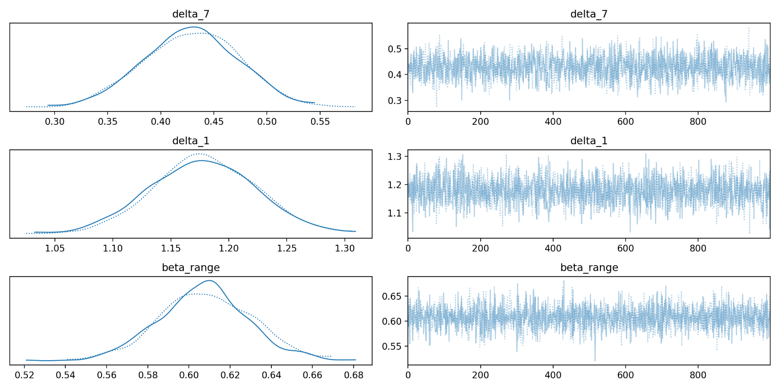
Figure 2. Posterior densities and trace plots from our NUTS run in the covariate-augmented model. Across both chains, the traces show stable mixing with no visible drift, and the posterior marginals are concentrated away from zero.
Prior Predictive Checking
We simulated log hazards from the prior predictive distribution and compared them to the observed distribution of log implied hazards in the modeling sample. Figure 3 shows that the prior predictive mass overlaps the observed distribution and is not wildly miss-scaled. This supports the claim that the priors are weakly informative rather than contradictory to the data.
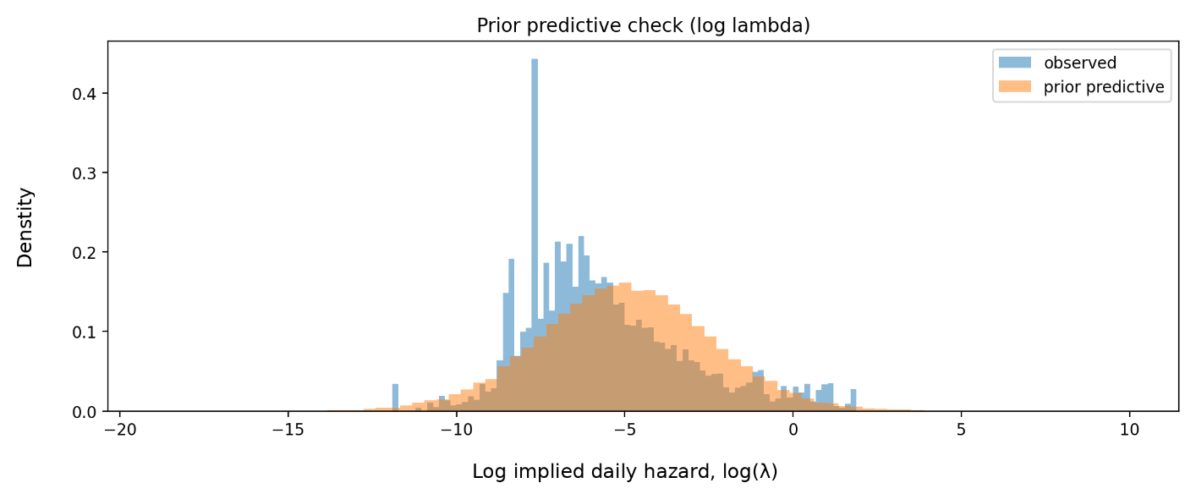
Figure 3. Prior predictive check on the log hazard scale. The prior predictive distribution overlaps the observed log implied hazards, indicating priors are on a reasonable scale.
Posterior Predictive Checking
We generated posterior predictive draws from the final covariate-augmented model and compared them to the observed distribution of log implied hazards. Figure 4 shows that the new posterior predictive distribution captures the central mass of the observed data more closely than the baseline model, although it still underrepresents the extreme right tail (very large hazards). This suggests that the added covariate improves fit in the bulk of the distribution, but that a Gaussian likelihood remains somewhat too light-tailed for the most extreme markets.
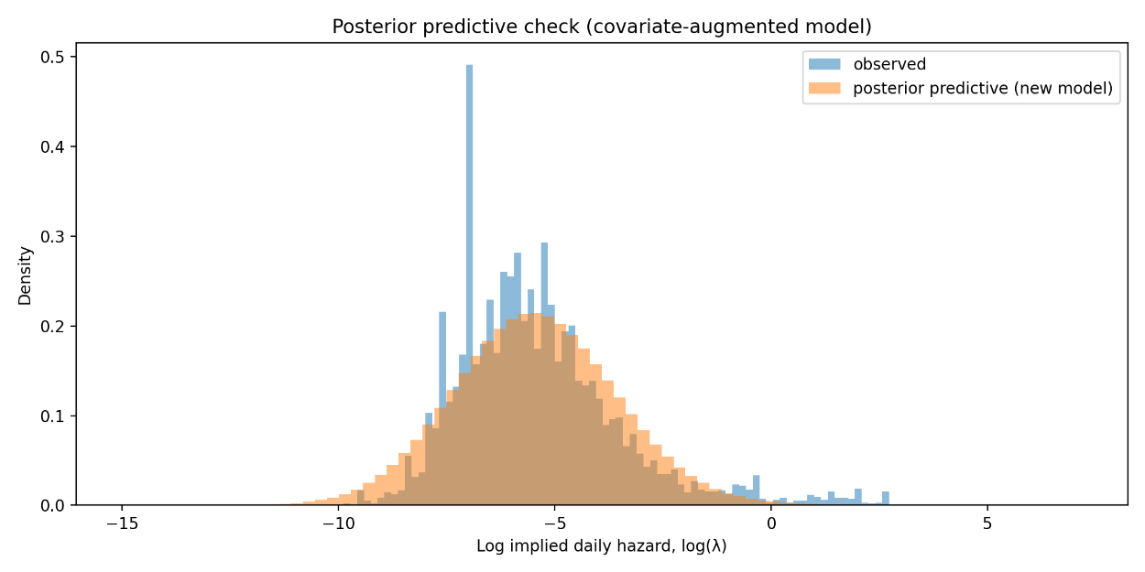
Figure 4. Posterior predictive check for the covariate-augmented hazard model on the log hazard scale. The posterior predictive distribution captures the bulk of the observed distribution more closely than the baseline model, although the extreme right tail remains underrepresented.
Prior Sensitivity
We conducted an additional sensitivity analysis on the final covariate-augmented model using a tighter prior on the horizon-effect scale, replacing $σ_{δ} HalfNormal(1)$ with $σ_{δ} HalfNormal(0.5).$ Next, we summarized this sensitivity analysis using ADVI. The posterior summaries were essentially unchanged: $δ_{7d}$ had a posterior mean of 0.426 with 94% HDI [0.293, 0.558], $δ_{1d}$ had a posterior mean of 1.183 with 94% HDI [1.045, 1.319], and $β_{range}$ had a posterior mean of 0.613 with 94% HDI [0.511, 0.717]. These are extremely close to the main-model estimates, indicating that the positive 7-day effect, the strong 1-day effect, and the positive local-activity covariate effect are not fragile artifacts of the default prior scale.
Results
Descriptive Term Structure
Figure 1 already shows that implied hazards increase as the deadline approaches when summarized on the log scale. In the modeling sample, the mean log implied hazard rises from about −6.59 at 30 days to −6.43 at 7 days and then to −5.64 at 1 day. The increase is concentrated very close to the deadline, consistent with the idea that the “1-day regime” is meaningfully different from the “30-day regime” in implied timing dynamics.
Posterior Estimates of Horizon Effects
Table 1 summarizes the posterior for $δ_{7d}$and $δ_{1d}$ under both of our inference methods. The key quantity is $exp(δ)$, which is the hazard multiplier relative to the 30-day baseline.
Inference method | Parameter | Mean δ (log) | 94% HDI for δ (log) | exp(mean δ) | 94% HDI for exp(δ)
ADVI | δ_7d | 0.433 | [0.358, 0.510] | 1.54 | [1.43, 1.67]
ADVI | δ_1d | 1.174 | [1.094, 1.241] | 3.24 | [2.99, 3.46]
ADVI | β_range | 0.609 | [0.567, 0.654] | 1.84 | [1.76, 1.92]
NUTS | δ_7d | 0.429 | [0.348, 0.512] | 1.54 | [1.42, 1.67]
NUTS | δ_1d | 1.178 | [1.095, 1.264] | 3.25 | [2.99, 3.54]
NUTS | β_range | 0.608 | [0.565, 0.650] | 1.84 | [1.76, 1.92]
Table 1. Posterior horizon effects and covariate effect in the covariate-augmented hazard model. Intervals are 94% HDIs.
The covariate-augmented ADVI and NUTS fits agree closely on our main conclusion. After controlling for event-level heterogeneity and local pre-snapshot price activity, the 7-day horizon effect remains clearly positive, with $δ_{7d}≈0.43$. On the hazard scale this corresponds to a multiplier of about 1.54 relative to the 30-day baseline. The 1-day effect is substantially larger: $δ_{1d}≈1.18$, corresponding to a hazard multiplier of about 3.25 relative to 30 days. This indicates that the implied daily hazard accelerates sharply as the deadline approaches, and that the effect is not explained away by local short-term market activity.
The covariate itself is also strongly positive. The estimate $β_{range}≈0.61$ implies that a one standard deviation increase in standardized log(1 + price_range_24h) is associated with an approximately 1.84-fold increase in implied daily hazard. In other words, local pre-snapshot price activity is meaningfully associated with faster implied event-arrival dynamics, but even after accounting for it, the horizon effects remain large and highly robust.
Trading application: spread strategy with analytical Bayesian updating
The hazard term-structure result motivated a downstream trading problem: if near- and far-horizon contracts on the same event exhibit systematic differences in implied hazard, then the spread between those contracts may contain exploitable structure. We implemented a spread-dynamics trading strategy that conditions on volume regimes and sizes positions using analytical Bayesian updating under a conjugate Normal–Normal model.
The strategy classifies market states using a volume z-score. Volume spikes are treated as a “news” regime, in which widened spreads are expected to compress; low-activity periods are treated as an “inactive” regime, in which spreads may continue to drift wider. Two trade types are used. Compression trades enter when the spread has recently widened and activity spikes, taking a short position in the far leg and a long position in the near leg. Widening trades do the reverse during inactivity regimes. Position sizing is handled analytically rather than via sampling: for each traded pair, the expected edge is modeled with a Normal prior and updated in closed form after observing trade outcomes under a Normal likelihood. The posterior mean and posterior variance are then fed into a Bayesian Kelly-style sizing rule.
In our backtests, this strategy appears statistically disciplined but economically thin. Starting from $10,000, the portfolio finished at $10,013.54, corresponding to a total return of 0.14% and a CAGR of 0.07%. Risk-adjusted performance was stronger than the nominal return would suggest, with a Sharpe ratio of 3.69, Sortino ratio of 6.64, maximum drawdown of 0.01%, and a 56.22% win rate across 21,253 trades. Posterior updating materially reduced uncertainty: across 2,227 traded pairs, average posterior standard deviation fell from 0.05000 to 0.01447 after 11,253 observations, corresponding to about a 71.1% reduction. Adding a factor and increasing the threshold did not materially improve performance. Overall, the spread signal appears measurable and Bayesian updating helps with sizing under uncertainty, but the current implementation is unlikely to be attractive after realistic slippage and fees due to its extremely high turnover and tiny nominal edge. Figure 5 shows the cumulative PnL of Bayesian uncertainty-aware sizing relative to the classic Kelly benchmark.

Metric | Value
Starting Capital | $10,000
Ending Capital | $10,013.54
Annual return | 0.07%
Total Return | 0.14%
Sharpe Ratio | 3.69
Sortino Ratio | 6.64
Win Rate | 56.22%

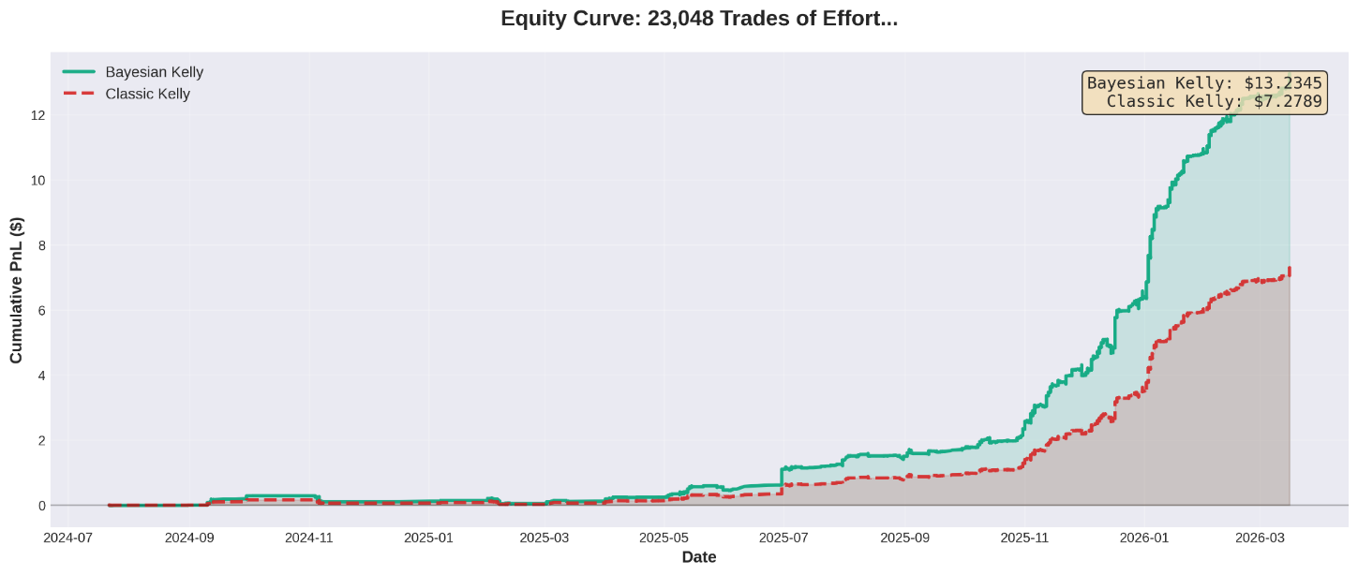
Figure 5. Equity curve for the spread strategy. Bayesian uncertainty-aware sizing outperforms the classic Kelly baseline in cumulative PnL, although the absolute return remains economically modest.
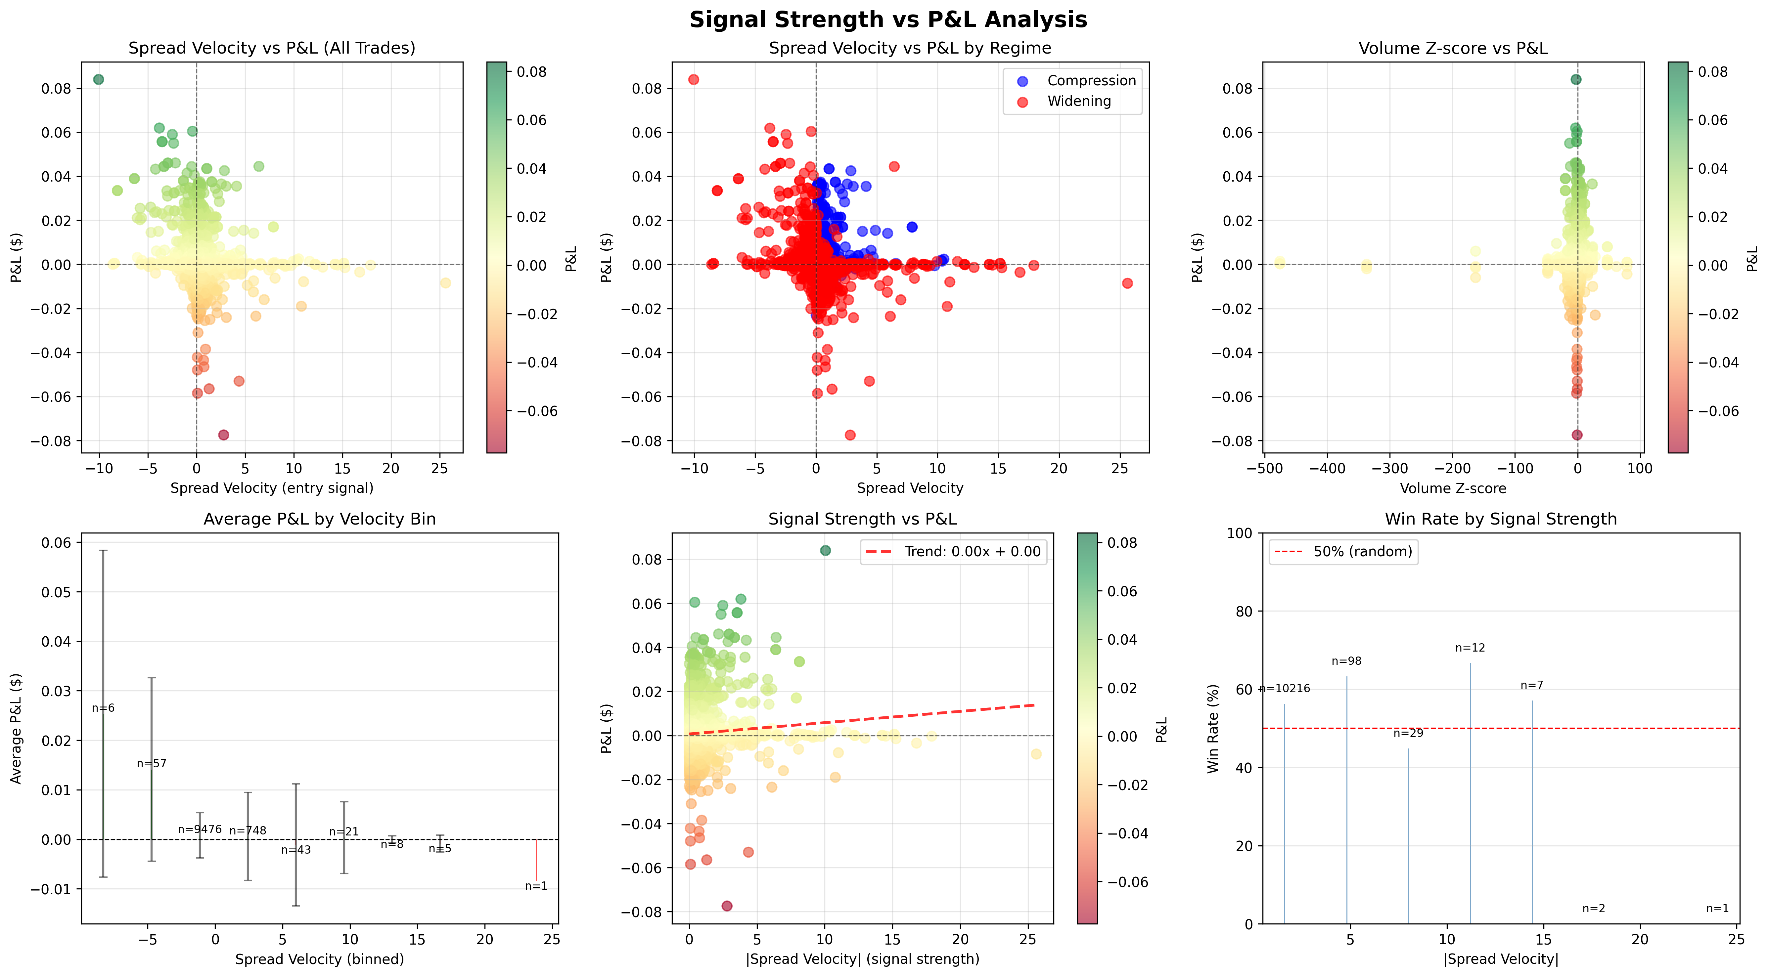
Figure 6. The signal is noisy and would require further filtering to trade profitably
Discussion
Our results indicate a clear term structure in Polymarket deadline markets when prices are translated into implied hazards. Figure 1 shows this directly on the log hazard scale, and the hierarchical Bayesian model confirms it after accounting for event-to-event heterogeneity and local pre-snapshot price activity. The 1-day effect is strongest, but the 7-day effect is also clearly positive in the final covariate-augmented model. The variational approximation (ADVI) and the full NUTS posterior agree closely on these main effects, and the NUTS diagnostics support stable inference under our final model specification. Moreover, there are at least two plausible mechanisms for the observed “1-day effect”. One is an information and attention story: as a deadline approaches, traders focus on the market, relevant news arrives, and updating accelerates. Another is a mechanical scaling story: because λ depends roughly on $\frac{p}{t}$ for small p, shrinking t can raise implied daily hazard even if p stays flat or declines modestly. Our analysis is primarily descriptive in the sense that we estimate the effect and quantify uncertainty, but we do not isolate causality.
Model limitations are visible in the posterior predictive checks. The final covariate-augmented posterior predictive distribution still underrepresents the extreme right tail of log hazards. This likely reflects a mismatch between a light-tailed Normal likelihood and occasional extreme market dynamics. A straightforward extension would replace the Normal likelihood with a Student-t likelihood, include a mixture component for outlier markets, or allow σ to vary with liquidity proxies. These extensions would be valuable if the goal were a better generative model of the full distribution, but they are not required to support the headline conclusions about $δ_{1d}$ and $δ_{7d}$, which remain strongly positive.
Furthermore, our trading application served as the second stage of the project. Our hazard model establishes that deadline structure matters, while the spread strategy tests whether that structure can be converted into a usable trading signal. The answer here appears to be “partly”: Bayesian updating improves sizing and regime-based spread trading produces favorable risk-adjusted metrics, but the raw economic edge is small and likely fragile after trading frictions.
Conclusion
Polymarket deadline-style markets exhibit a strong and systematic horizon effect when interpreted through implied event-arrival hazards. In the final covariate-augmented hierarchical model, the implied daily hazard at about 7 days to deadline is estimated to be roughly 1.54 times the 30-day baseline, while the implied daily hazard at about 1 day to deadline is estimated to be roughly 3.25 times the 30-day baseline. These results are consistent across ADVI and a full NUTS run with clean diagnostics, and they remain strongly positive even after controlling for local pre-snapshot price activity. The trading application shows that this term-structure signal can be turned into a statistically disciplined spread strategy, but current profitability is economically modest once practical market frictions are considered.
Reproducibility and Code
All processing and analysis steps are reproducible from the project repository. The SQLite database is not committed to Git due to size, but the analysis assumes polymarket.db is present locally with the expected schema. The SQL pipeline used to identify timing markets, join price histories, construct horizon snapshots, and compute local activity covariates is recorded in analysis_pipeline.sql, with interactive querying performed in Beekeeper Studio. The final exported table used for the covariate-augmented model is timing_model_input_bft_cov2.csv.
Model fitting, inference, and plotting were performed in Python using PyMC and ArviZ. The main scripts for the final model are run_lambda_model_covrange_collapsed.py (ADVI + full NUTS fit), plot_diagnostics_covrange.py (posterior density and trace plots), and ppc_covrange.py (posterior predictive checking). Running these scripts after rebuilding the analysis table reproduces the main numerical summaries and model-based figures in this report. Lastly, an additional prior-sensitivity analysis for the final model was run with run_lambda_model_covrange_sensitivity.py and summarized using summarize_covrange_sens_advi.py.
References
Abril-Pla, O., Andreani, V., Carroll, C., Dong, L., Fonnesbeck, C. J., Kochurov, M., Kumar, R., Lao, J., Luhmann, C. C., Martin, O. A., Osthege, M., Vieira, R., Wiecki, T., & Zinkov, R. (2023). PyMC: A modern and comprehensive probabilistic programming framework in Python. PeerJ Computer Science, 9, e1516.
Beekeeper Studio. (n.d.). Beekeeper Studio: SQL editor and database manager [Computer Software]. (Used for SQLite query execution during the project).
Frederick, S., Loewenstein, G., & O’Donoghue, T. (2002). Time discounting and time preference: A critical review. Journal of Economic Literature, 40(2), 351–401.
Hoffman, M. D., & Gelman, A. (2014). The No-U-Turn sampler: Adaptively setting path lengths in Hamiltonian Monte Carlo. Journal of Machine Learning Research, 15, 1593–1623.
Kucukelbir, A., Tran, D., Ranganath, R., Gelman, A., & Blei, D. M. (2017). Automatic differentiation variational inference. Journal of Machine Learning Research, 18(14), 1–45.
Kumar, R., Carroll, C., Hartikainen, A., & Martin, O. (2019). ArviZ a unified library for exploratory analysis of Bayesian models in Python. Journal of Open Source Software, 4(33), 1143.
Polymarket. (n.d.). Polymarket platform data exports used in this project (downloaded during the project period).
Wolfers, J., & Zitzewitz, E. (2004). Prediction markets. Journal of Economic Perspectives, 18(2), 107–126.

